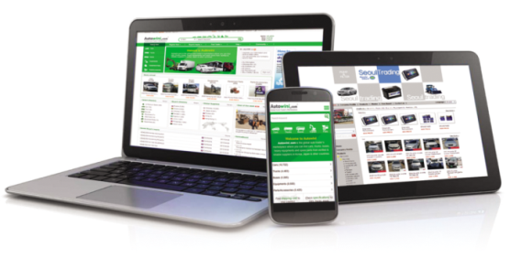
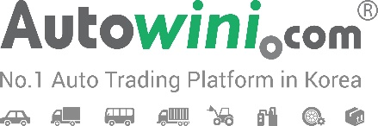

Autowini - No.1 Auto Trading Platform in Korea
Platform Translator for Arabic / Swahili Speakers
Autowini.com is the No.1 global auto trading platform in Korea which enables overseas customers to buy cars, trucks, buses from Korea’s local suppliers directly. Autowini has been launched in 2010 and growing as the fascinating & working marketplace with more than 100 countries customers all over the world. Not only with the young energy and enthusiasm, but also we have a clear vision, growth plan, good people and culture. Join us and develop the world’s most innovative automobile trading platform!
JOB DESCRIPTION
- Position : Overseas Marketer for African Countries
- Main Job : Customer Support & Overseas Sales, Marketing, Translation, Platform Management

JOB REQUIREMENT
- Nationality in African Countries
- Bachelor’s degree graduate (KGSP Sudents)
- Fluent communication skills in English & Korean (French or Kiswahili also preferred)
- Interest in automotive industry
- Bright, Positive and proactive mindset, Humble mind & Strong responsibility

CONDITION OF EMPLOYMENT
- Salary : 2,000,000 KRW / month
- Working hours : Mon. to Fri. 6 PM – 3 AM (Night time working)
- Work location : Autowini Inc. 8th floor, IB Tower Bldg, 19-7, Nambusunhwan-ro 350-gil,
Seocho-gu, Seoul (5 minutes walk from Exit 5, Yangjae, 3 Line)
- Working period : 6 months – After, you can be turned into a 1 year contract employee after finishing the period with good performance

SUBMIT RESUME
- Send us Resume at dh.lee@autowini.com
- Inquiry : 02-576-5533 (Mr. Lee Donghan, HR)
- For detailed company information, please visit www.Autowini.com.
Thank you for your interest in Autowini. Wish you all the best.

